Jaguar and Panther Performance Data analysis report

Name: Andrei Kyo D. Medel

Course: CPE2A

Introduction:

Due to the received feedback about inconsistent performance metrics of the two key equipment respectively named “Jaguar” and “Panther”, The operations manager has sent out a task to conduct a descriptive statistical analysis for the recent performance data of the two.

Purpose:

The purpose of this report is to present and the summarized findings of the descriptive statistical analysis based on the results found within the performance data when both machines were used to produce 1K ohm resistors.

Objectives:

The main objectives of this report is to analyze the performance metrics of Jaguar and Panther equipment based on recent data provided and to offer insights into their efficiency as well as their consistency.

Key Metrics Analyzed:

The Statistical Metrics were computed and analyzed for the performance data are as follows:

1. Mean
2. Median
3. Mode
4. Range
5. Variance
6. Standard Deviation
7. Coefficient of Variation(CV)

Performance Data

Below are the values on the performance data provided for this analysis report

|  |  |  |
| --- | --- | --- |
| Lot_No | Jaguar | Panther |
| 1 | 997 | 1035 |
| 2 | 1153 | 975 |
| 3 | 920 | 982 |
| 4 | 1074 | 1038 |
| 5 | 1013 | 891 |
| 6 | 960 | 907 |
| 7 | 890 | 960 |
| 8 | 910 | 978 |
| 9 | 944 | 1041 |
| 10 | 1065 | 1026 |
| 11 | 1083 | 590 |
| 12 | 1820 | 990 |
| 13 | 859 | 1076 |
| 14 | 1043 | 1092 |
| 15 | 1710 | 1026 |
| 16 | 933 | 935 |
| 17 | 790 | 1710 |
| 18 | 999 | 946 |
| 19 | 1028 | 1073 |
| 20 | 976 | 986 |
| 21 | 1015 | 1078 |
| 22 | 932 | 969 |
| 23 | 957 | 1083 |
| 24 | 936 | 790 |
| 25 | 977 | 1007 |
| 26 | 1037 | 934 |
| 27 | 997 | 999 |
| 28 | 1730 | 1011 |
| 29 | 1046 | 942 |
| 30 | 1840 | 1090 |

Boxplots

The images below are Boxplots for the Jaguar and the Panther equipment based on the recent performance data values provided are displayed below, these are used to hypothesize the consistency of the performance for each equipment.

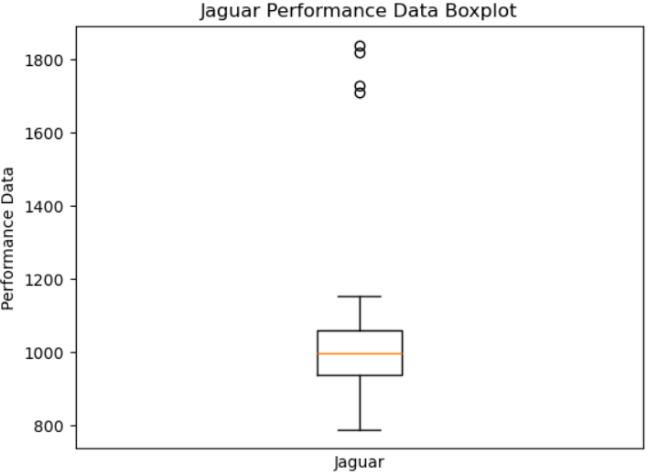

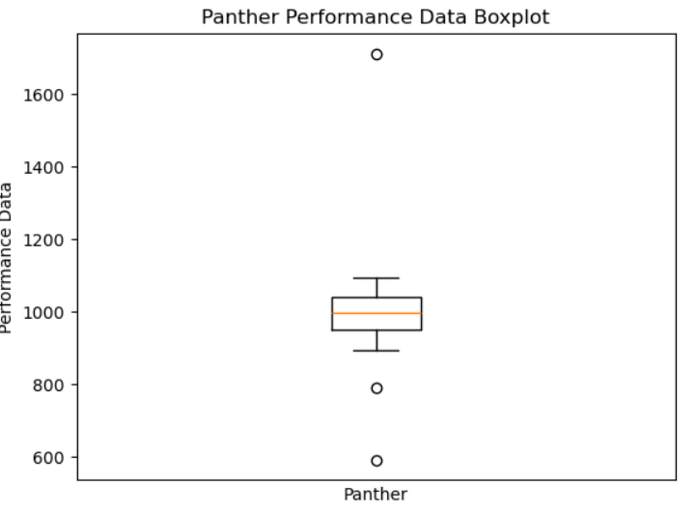

Mean

The mean is the average or the most common value in a collection of numbers

Jaguar:

997 + 1153 + 920 + 1074 + 1013 + 960 + 890 + 910 + 944 + 1065 + 1083 + 1820 + 859 + 1043 + 1710 + 933 + 790 + 999 + 1028 + 976 + 1015 + 932 + 957 + 936 + 977 + 1037 + 997 + 1730 + 1046 + 1840 = 32,634 (sum)

Mean = sum/number of values

33,979/30 = 1,087.8

The mean for the Jaguar equipment is **1,087.8**.

Panther:

1035 + 975 + 982 + 1038 + 891 + 907 + 960 + 978 + 1041 + 1026 + 590 + 990 + 1076 + 1092 + 1026 + 935 + 1710 + 946 + 1073 + 986 + 1078 + 969 + 1083 + 790 + 1007 + 934 + 999 + 1011 + 942 + 1090 = 30,136 (sum)

30,136/30 = 1,004.53

The mean for the Panther equipment is **1,004.53**.

Median

The Median is the value lying at the midpoint of a frequency distribution of observed values, such as that there is an equal probability of falling above or below it.

Jaguar:

790, 859, 890, 910, 920, 932, 933, 936, 944, 957, 960, 976, 977, 997, 997, 999, 1,013, 1,015, 1,028, 1,037, 1,043, 1,046, 1,065, 1,074, 1,083, 1,153, 1,710, 1,730, 1,820, 1,840

Median in even amount of numbers = average of two middle numbers

997 + 999/2 = 998

The Median of the Jaguar equipment is **998**.

Panther:

590, 790, 891, 907, 934, 935, 942, 946, 960, 969, 975, 978, 982, 986, 990, 999, 1,007, 1,011, 1,026, 1,026, 1,035, 1,038, 1,041, 1,073, 1,076, 1,078, 1,083, 1,090, 1,092, 1,710

Two middle numbers = 990 and 999

990 + 999/2 = 994.5

The Median of the Panther equipment is **994.5**.

Mode

The mode is the value that appears the most often in a set of data values

Jaguar:

The value that appeared the most often for the Jaguar equipment is **997** as it appeared a total number of **two times**.

Panther:

The value that appeared most often for the Panther equipment is **1,026** as it appeared a total number of **two times**.

Range

The range of a data set is the difference between the highest and the lowest values.

Jaguar:

The highest value for Jaguar is 1,840

The lowest value is 790

1,840 - 790 = 1,050

The range of the Jaguar equipment is **1,050**.

Panther:

The highest value for Panther is 1,710

The lowest is 590

1,710 - 590 = 1,120

The range of the Panther equipment is **1,120**.

Variance

The variance is a statistical measurement of the spread between numbers in a data set.

Jaguar:

Mean = 1,087.8

$$s^{2}=\frac{{\sum_{i=1}^{n}{(x_{i}}−x)}^{2}}{n−1}$$

$$s^{2}= \frac{2341744.8}{30−1}$$

$$s^{2}=80,749.821$$

The Variance for Jaguar is **80,749.82**.

Panther:

Mean = 1,004.53

$$s^{2}=\frac{{\sum_{i=1}^{n}{(x_{i}}−x)}^{2}}{n−1}$$

$$s^{2}= \frac{801,642.67}{30−1}$$

$$s^{2}=27642.851$$

The Variance for Panther is **27,642.85**.

Standard Deviation

The Standard Deviation is a measure of how dispersed the data is in relation to the mean.

To get the Standard Deviation, take the square-root of the Variance.

Jaguar:

The square-root of Jaguar’s performance data Variance is **284.17**.

Panther:

The square-root of Panther’s performance data Variance is **166.26**.

Coefficient of Variation

The coefficient of variation is the ratio of the standard deviation to the mean

To get the Coefficient of Variation, divide the Standard Deviation by the Mean.

Jaguar:

Jaguar Mean = 1,087.8

Jaguar Standard Deviation = 284.17

284.17/1,087.8 = 0.26

The Coefficient of Variation of Jaguar’s performance Data is **0.26**.

Panther:

Panther Mean = 1,004.53

Panther Standard Deviation = 166.26

166.26/1,004.53 = 0.16

The Coefficient of Variation of Panther’s performance Data is **0.16**.

Summary

This is the compilation of all the values calculated from the given performance data for both Jaguar and Panther equipment when used to make 1K ohm resistors.

Jaguar:

Mean: 1,087.8

Median: 998

Mode: 997

Range: 1,050

Variance: 80,749.82

Standard Deviation: 284.17

Coefficient of Variation: 0.26

Panther:

Mean: 1,004.53

Median: 994.5

Mode: 1,026

Range: 1,120

Variance: 27,642.85

Standard Deviation: 166.26

Coefficient of Variation: 0.16

Conclusion

* In comparison to Panther, the Jaguar data set has more dispersion and less consistency due to its higher mean, larger range, and greater variability (as indicated by variance and standard deviation).
* Compared to Jaguar, the Panther data set is more consistent since it is more centered around its mean and has less variability.
* Jaguar's data set is more skew and variable, while Panther's is more concentrated and steady.
* Panther provides a more stable and consistent data set, while Jaguar exhibits more variability, wider ranges, and greater deviation from the mean.
* If precision and consistency are key, Panther is more reliable, whereas Jaguar may be more variable and less predictable due to it’s volatility.